Practical Implementation of all the Task

Shell Script
- Fundamentals of Shell Script
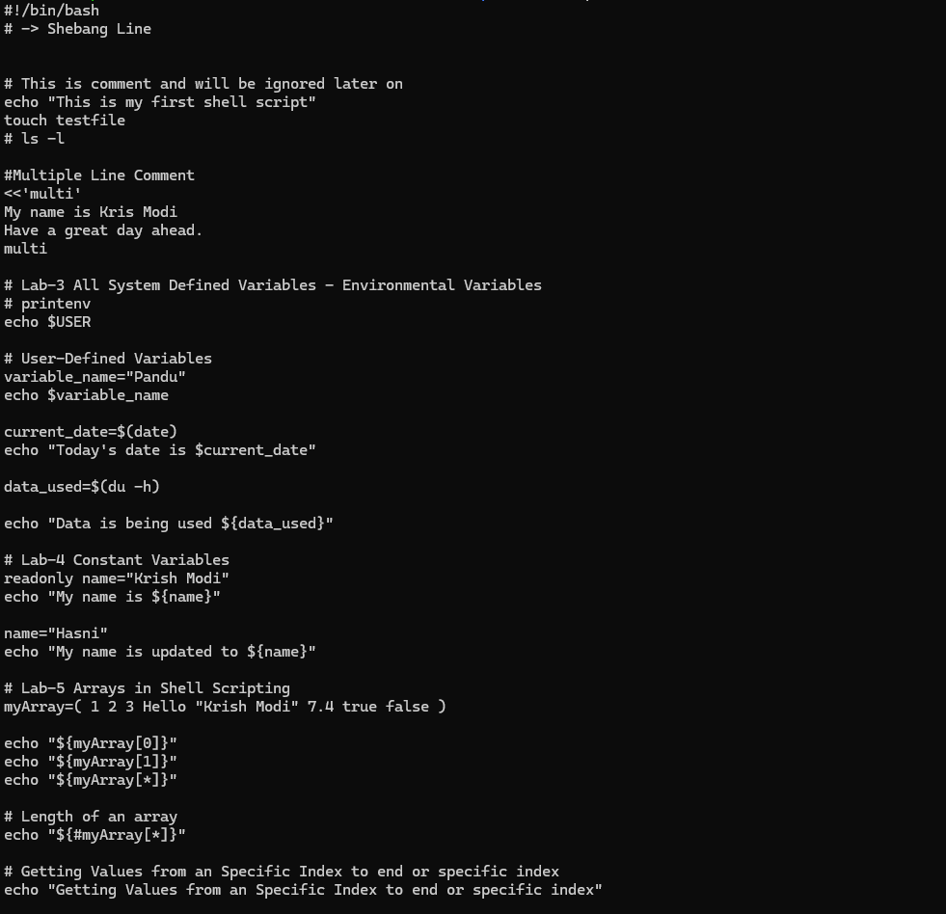
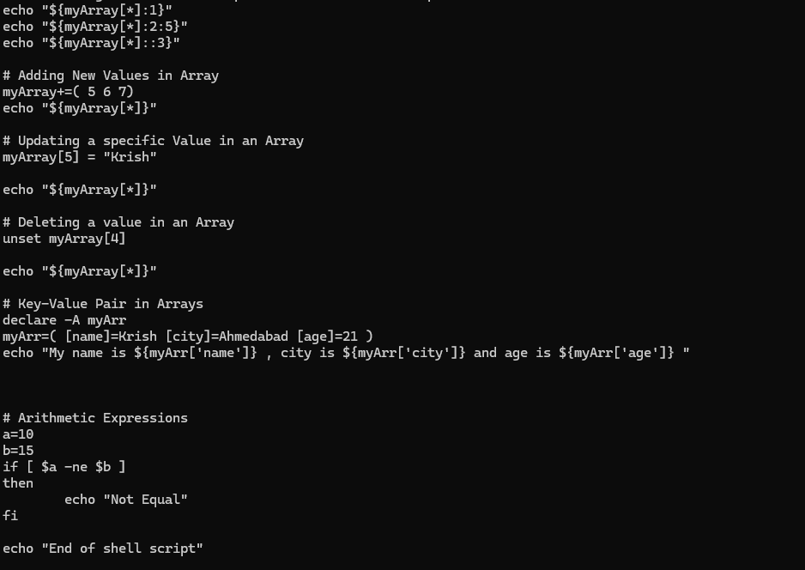
- Create a dice game in shell script
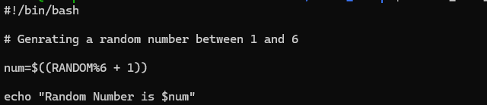
- Create a directory for all the month in a year
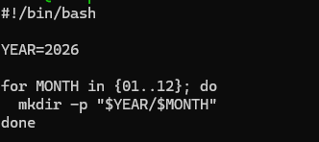
- Make passwordless connections to different account in VM
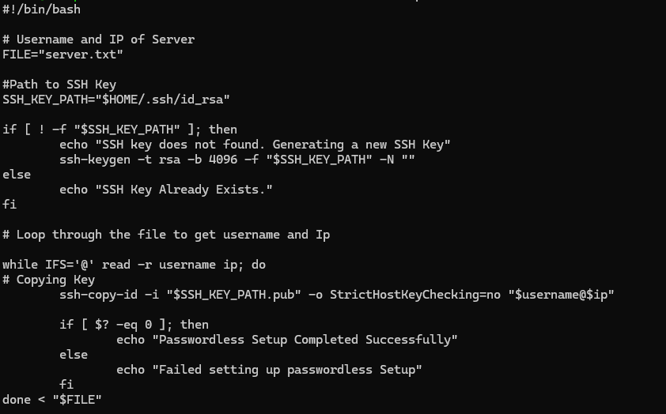
- Store all the files based on given conditions
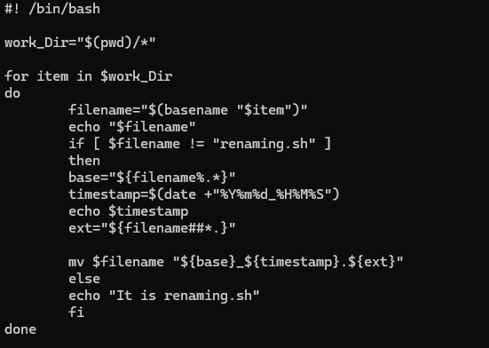
- CronJob Task – Create a notification system at specific time of a Day based on DT-DevOps Azure account

Git Commands

Docker
- Create a simple docker file
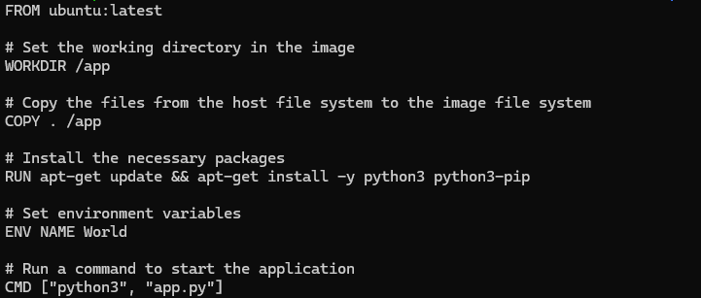

- Run a python web application using Docker
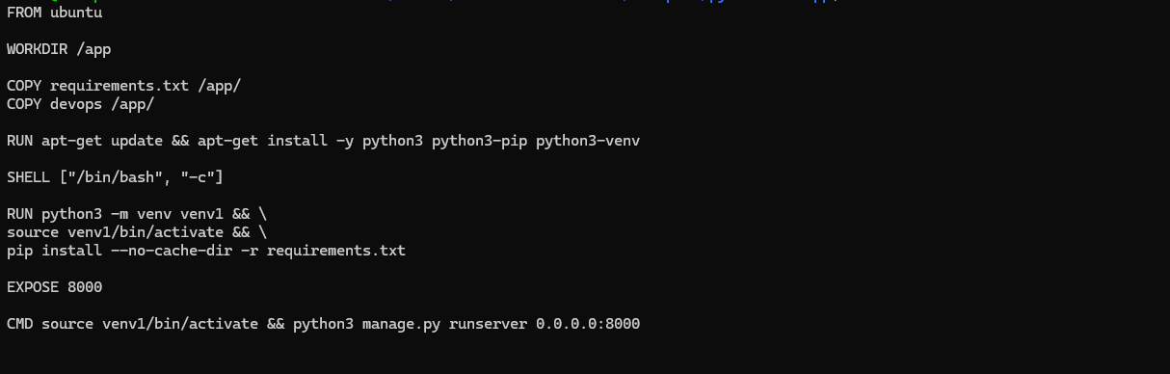
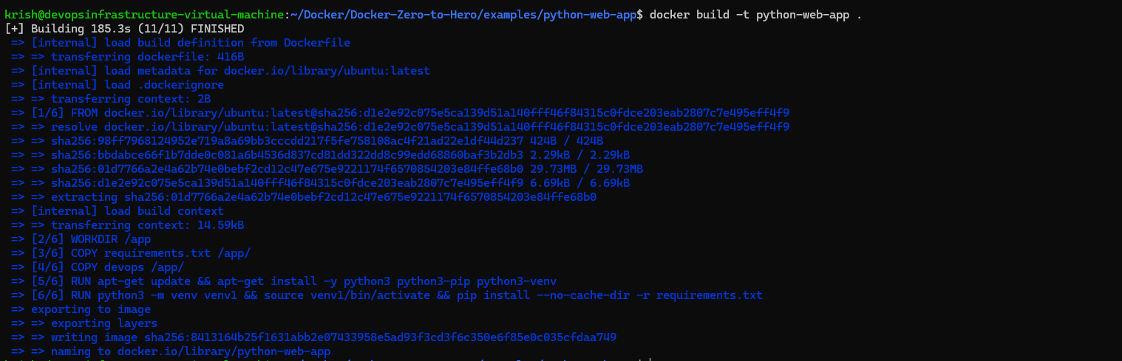
- Docker Multi-Stage Build
Golang File
  - Without Multi-Stage

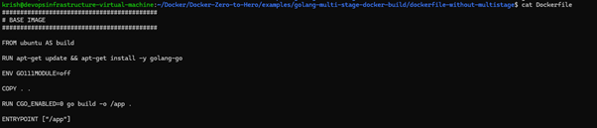

Storage used without Multi-Staged

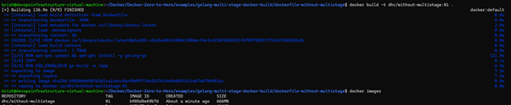

  - With Multi-Stage
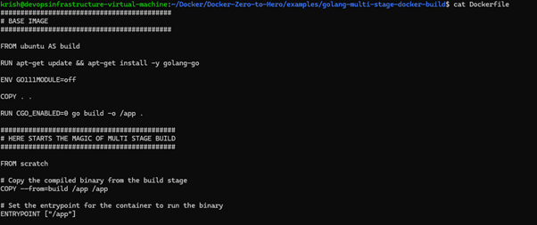
Storage used with Multi-Stage

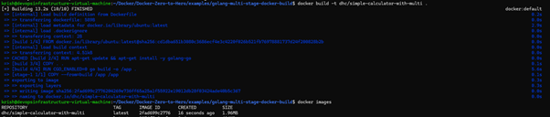

- Docker Volume
Practical Implementation Of Docker Volume
  - File Structure

  - Myapp.js

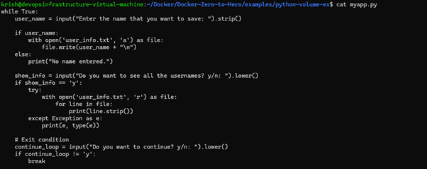
  - Dockerfile

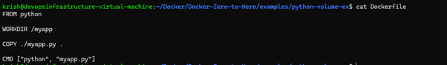

  - Creating Docker Image

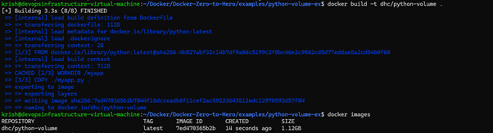

  - Running docker container

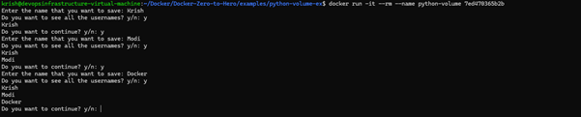

Contents of user_info while container is still running

User_info gets-empty once container is killed.
So cause of this, docker Volumes came into actions.
  - Creating Docker Volume

Running docker Container

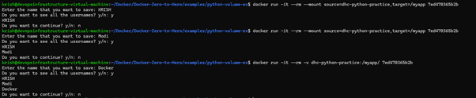
OR
Creating and running container at the same time

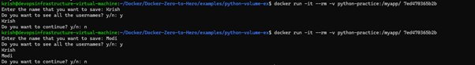

- Docker Bind-Mount
Create a docker image
Run the docker container with mount
Before Bind Mount

After Bind Mount
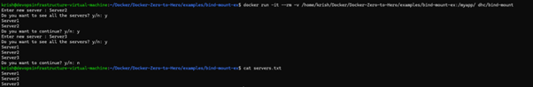

- Docker Networking

Practical Implementation of Docker Networking
  - Bridge Networking
Container 1 à dhc-login
  - Running Docker container

  - Install ping
    - Docker exec -it dhc-login /bin/bash

  - Apt updates

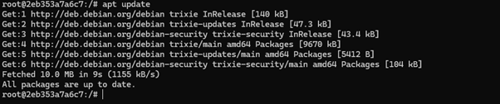

  - apt install iputils-ping -y

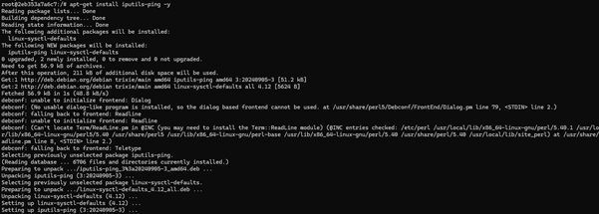

  - ping -V

Container 2 à dhc-logout
  - Running Docker container

  - Install ping
    - Docker exec -it dhc-login /bin/bash

  - Apt updates

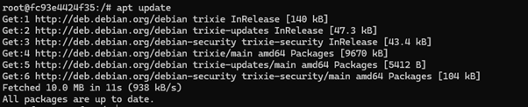

  - Apt-get install iputils-ping -y

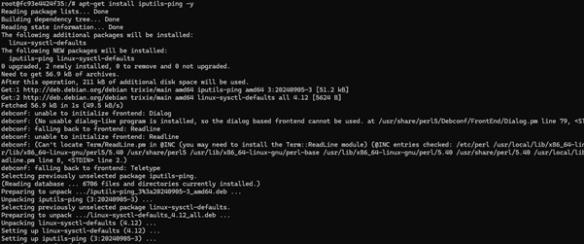

  - ping -V

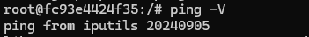

  - docker inspect dhc-login

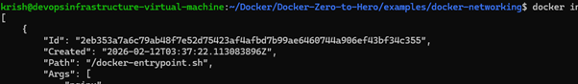

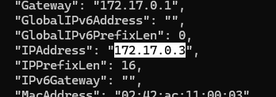

Docker inspect dhc-logout

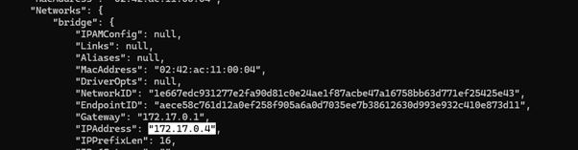

  - login container interacting with logout container

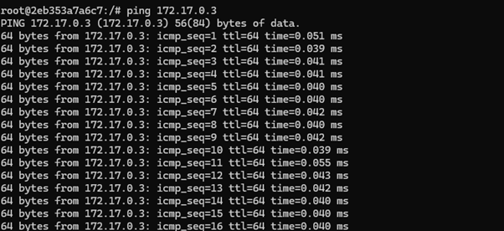
  - User-defined Networking
  - Create new network à security-network

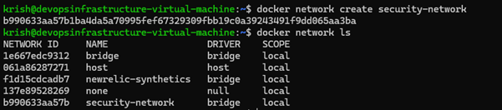
  - Creating a new container with the above network

  - Inspecting this container – type: security-network, IPAddress

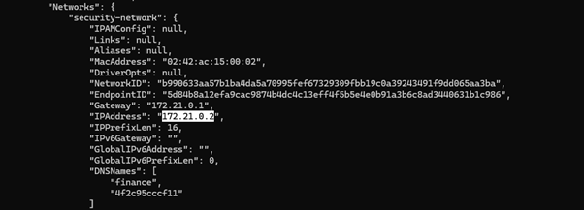
  - Trying to access this container from dhc-login container

  - Now adding dhc-login container to security-network

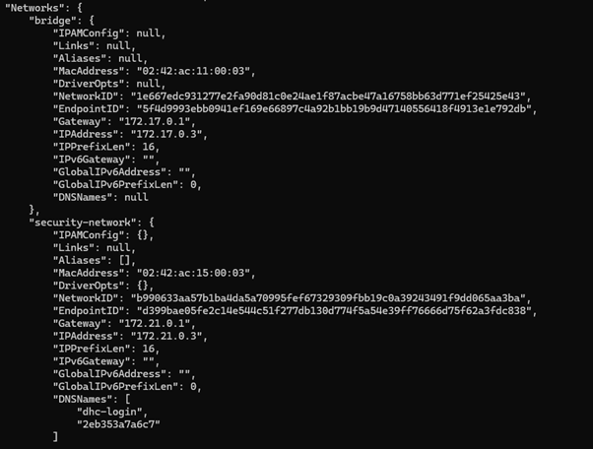
  - Login container interacting with finance container

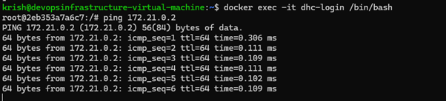
  - Disconnecting dhc-login from Security-network

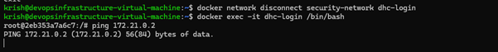
  - Creating host driver-network

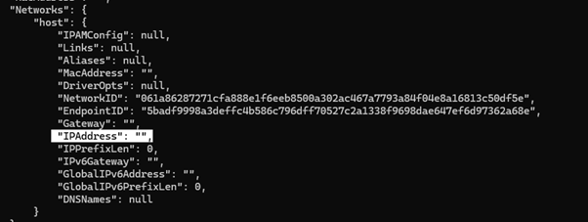

- Practical Implementation of Docker to Showcast, what I have learned as an project

EXAMPLE 2 à Connecting my Own Web Application
Change in Docker-Compose File

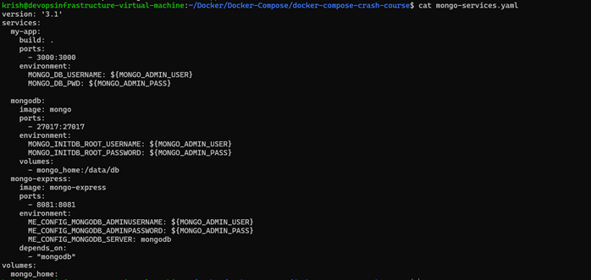

As mongo and mongo-express were already running, we run the compose file to that container directly.

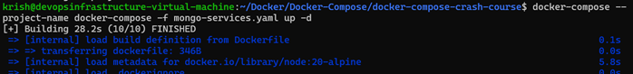
Docker Allows Variables

OUTPUT

